BITE SIZED GOVERNMENT & POLITICS:

A STUDENT GUIDE

CHAPTER ONE
POLITICS: WHAT’S IT ALL ABOUT?

POLITICS & POWER
KEY CONCEPTS
Politics is about power. Whoever holds power can decide how to share out the nation’s resources. It therefore involves conflict resolution: deciding how to distribute limited resources between groups with competing claims and managing the business of government. Usually in a democracy, like Britain, it is the government, elected by the people, which holds power. The government therefore decides how Britain’s resources (money and services) should be distributed. This means that the government can determine how much we pay in taxes, or whether there should be university fees, or whether there should be a free National Health Service. In exercising political power governments can take countries to war, sign treaties, and help shape their economies.
In today’s complex world, exercising political power and trying to balance the competing demands for resources from citizens is far from easy. This is because political power reaches beyond government. Governments must answer to the electorate every five years in a general election; they must get their legislation (laws based of government politics) approved by parliament; they must respond to questions posed on our behalf by the media; and they must listen to pressure groups which represent different sectors of society, sometimes with countervailing (or competing) views. In a democracy, governments must be accountable for their actions.
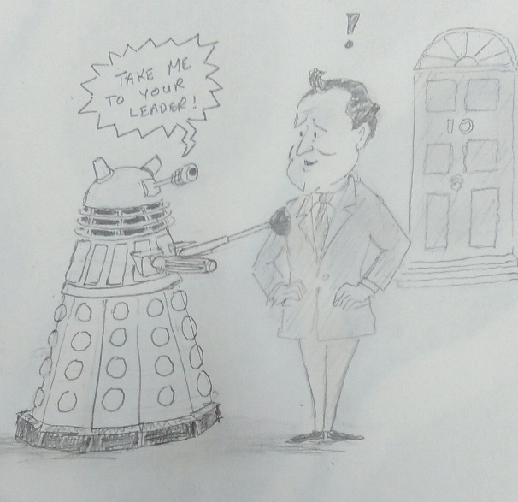
Political power also determines the values which dominate society. All aspects of our lives can be shaped by how much power we have to influence the political process and this can depend on such factors as social class, gender, ethnicity, religion, status and occupation.

DIFFERENT TYPES OF POWER:
Power is the ability of a person or group to make others do something they might not otherwise do. It relates to authority, which is the legal right to exercise power conferred on an individual or a body of people by the consent of the citizens of the state. Authority is often arises from a moral standpoint. There are different types of power and authority. Among them are:
Coercive power: the ability to threaten or ‘coerce’ someone to change their behaviour. Terrorists often resort to coercive power, for example, by holding hostages and making political demands for their release.
The Sociologist, Max Weber, identified three types of authority:
Traditional authority: the authority of someone because of tradition or custom. Monarchs often possess this.
Charismatic authority: the power of an individual to persuade others to do as they wish by the force of their personality. Hitler and Churchill are said to have possessed charismatic authority.

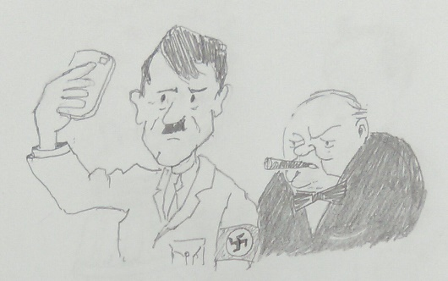

Legal-rational authority: the power granted to an individual or body of people by virtue of the office that they hold. A democratically elected government would be an example of a group holding legal-rational authority. Citizens accept the authority of such an institution. The police force would be another example.

EXAMPLES: The exercise of political power
Political parties might hope to implement their ideas when they gain power, but sometimes they find that once in government circumstances do not allow them to do so. There is no better example of this than the Greek anti-austerity party Syriza which was elected to reject EU proposals for tight budgetary controls in 2015, but which found itself having to agree to austerity measures imposed by the EU creditors.
In 2010 when the Conservatives and Liberal Democrats came to power to form a coalition government (a government made of two or more political parties) they quickly learned that Britain’s budget deficit (or debt) was bigger than they had imagined. Liam Byrne, Labour’s outgoing Secretary to the Treasury, had jokingly left a note on his desk which read, “Sorry there is no money left.” This meant that the coalition government felt it had to cut public services (because public services cost money) and raise university tuition fees in order to tackle the deficit. This was despite the fact that the Liberal Democrats has promised, during the election, that they would abolish university tuition fees and the Conservatives, in 2006, had promised to support the public sector. An alternative strategy would have been to raise taxes, but, in the UK, governments don’t like doing this as it makes them unpopular with the electorate.
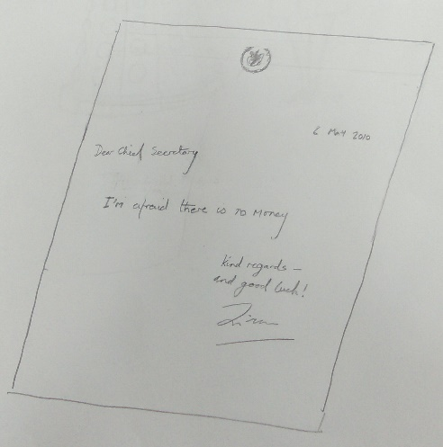
Public services are those services which are provided by the government or local or regional government, paid for largely through taxation. They include healthcare, education, the benefits system and pensions.
This is an interesting and useful definition.

In 2015 when the Conservative government was elected with an overall majority, the country continued to face a budget deficit. The chancellor, George Osborne, decided that his best strategy to manage the deficit was further budget cuts.
Every decision made by a government benefits some, but disadvantages others. This is because there is never enough money or resources to satisfy everyone’s needs. Who benefits and who loses out is a political decision.

HARD STUFF
The twentieth century philosopher, John Rawls, argued that the only way to distribute resources fairly in a society would be if those who made the decisions knew nothing about themselves. In other words, they would have no idea about their gender, ethnicity, age, disability, etc. That way they would not propose a policy which might disadvantage a particular social group because they would have no idea whether they belonged to that group and they would risk unwittingly disadvantaging themselves. He called this idea ‘the veil of ignorance’ and proposed that those who make the law would ideally be subjected to such a veil.

DEMOCRACY
STUFF YOU NEED TO KNOW
The word democracy comes from the Ancient Greek word ‘demokratia’; demos = ‘the people’ and ‘kratos’ = ‘rule of’: so ‘democracy’ literally means ‘rule of the people’.
So ‘aristocracy’ is the rule of the aristocrats, ‘theocracy’ is the rule of the church (or theologians), ‘technocracy’ is the rule of engineers and scientists (or technocrats), and ‘plutocracy’ is the rule of the wealthy (‘plutos’ is the Ancient Greek for wealth).
There are two types of democracy: ‘direct democracy’ and ‘representative democracy’.
Direct democracy is a system in which every citizen has a vote on each issue. This was true in some Ancient Greek city states, where every citizen could vote on all the issues facing them if they chose to (although slaves and women were not regarded as citizens!). The nearest we get to direct democracy today is referendums. These are a form of direct democracy in which citizens can vote on a single issue.
Representative democracy is a system in which a representative (for example a Member of Parliament) is elected by citizens to vote on issues on their behalf. Most modern democracies, including the UK and the USA, are representative democracies. In modern, complex societies citizens would not have the time or the resources to study the technical information necessary to cast an informed vote on every issue facing politicians. Modern representative democracies are also often known as liberal democracies.
Representative liberal democracies exhibit the following features:
- Free and regular elections
- Freedom of speech and free press
- A multi-party system
- The right to vote for all adult citizens (this is known as universal suffrage)
- Guaranteed rights of citizens
- Freedom of assembly (that is the freedom to march and protest)

EXAMPLES: Representative democracies
The United States is a good example of a representative democracy where a legislature (a law-making body) is elected. In the USA the legislature is Congress. It is made up of two elected chambers: the House of Representative and the Senate. This makes the US system of government more representative than the system in the UK because the UK parliament has one unelected chamber (the House of Lords) and one elected chamber (the House of Commons). In the USA two political parties dominate national politics: the Republicans and the Democrats. This used to be the case in British politics, but today there are many political parties which are represented in parliament. Among the most significant are the Conservative Party, the Labour Party, the Liberal Democrats, the Green Party, and UKIP, as well as the regional parties such as the SNP (from Scotland), Plaid Cymru (from Wales) and Sinn Fein, the SDLP, and the DUP (from Northern Ireland).
Having more than one party makes a society a pluralist (see pluralism below) democracy.

ADDITIONAL STUFF
Pluralism is a liberal democratic system where power is dispersed among different groups in society rather than concentrated in the hands of a few. The word ‘pluralism’ literally means ‘more than one’ (as in ‘plural’). In a pluralist society there will be more than one group seeking to hold or influence power. Pluralist democracies are characterised by a range of competing political parties seeking power and competing pressure groups seeking to influence those who are in power. Citizens have a choice of parties at election time and can join pressure groups to try to influence the policy-making process. Britain can be described as a pluralist society.
Elitism is a system, often contrasted with pluralism, in which power is concentrated in the hands of a privileged group, or ‘elite’. Sometimes democracies can be described as elitist because, although there are elections, the people who are elected come from a narrow socio-economic group. For example, David Cameron, George Osborne and Boris Johnson (all members of the 2015 government) all went to Eton public school. There is arguably also a connection (sometimes referred to as ‘the old boy network’ or ‘the Establishment’), through a common public school or university background, between members of the government and senior figures in the world of banking, commerce, industry, the civil service, the church and the armed forces. So…Britain can also be described as elitist.

HARD STUFF
The democratic paradox is the insoluble (unsolvable) question as to whether a party which seeks to end democracy should be allowed to stand in democratic elections. It is a question which is sometimes retrospectively posed in relation to the Nazi Party in Weimar Germany.
You don’t need to know this definition. It’s just interesting.

POLITICAL PARTICIPATION
STUFF YOU NEED TO KNOW
Political participation can be both formal and informal.
Formal participation involves those activities which we would easily recognise as being part of the mainstream political process. It includes:
- voting at elections,
- joining a political party,
- being an activist within a party, or
- standing for political office (for example, standing to become a councillor in a local election, or an Member of Parliament in a general election).
Informal participation involves less direct ways of influencing the policy-making process. It includes:
- joining a pressure group or social movement (such as Greenpeace, Amnesty International, or Occupy, or
- protesting by joining a march or attending a political rally or signing a petition.

EXAMPLES
In recent years political scientists who study voting behaviour (they are known as psephologists) have seen a decline in formal participation in British politics and a rise in informal participation. The decline in formal participation is evidenced in two ways: 1) a reduction in turnout and 2) a decline in the membership of mainstream political parties.

Turnout:
Turnout is the number of people who are eligible to vote who actually do vote (or ‘cast a ballot’) measured as a percentage. In the 1950s turnout at general elections was regularly above 80%. In 1950 it was as high as 83.9%. By the late 1970s turnout was still as high as 75% (1979 & 1987). But in 2001 it dropped to an all-time low of 59%. Despite a modest rise in recent elections (2005: 61%; 2010: 65%; and 2015 67%) it is still not back to the levels of the last century.

Membership of political parties:
The membership of most mainstream political parties has been in decline. In 1953 the Conservative Party had 2.8 million members, and the Labour Party 1 million members. In January 2015 the Conservatives had about 149,000 members and the Labour Party 190,000 members (although the inclusion of the popular left-wing anti-austerity candidate, Jeremy Corbyn, in the Labour leadership contest in 2015, saw membership increase by 79,000, to almost 300,000, and an additional 145,00 ‘registered supporters’). The Liberal Democrats, who claimed 100,000 members in the 1990s, had 44,000 members in January 2015. This rose to 60,000 after the 2015 general election.
Bucking the trend in January 2015 the SNP had 93,000 members and was growing and UKIP 42,000 members and was also growing. This is evidence of growing fragmentation within British politics.
In contrast, informal participation, such as membership of pressure groups and attendance at mess demonstrations has increased in this period. Pressure groups such as the RSPB (which act to protect bird habitats) stands at over 1 million, while the National Trust (which preserves historic houses and landscapes) have over 4 million members. Among the more sizable marches and demonstrations in recent times was the ‘Stop the Iraq War’ demonstration in Hyde Park in 2003, which, according to the organisers, saw over three million protesters gather. In March 2011 an anti-austerity march in London reached 400,000.
Consequently the POWER inquiry into Britain’s democracy in 2006 looked at the apparent growing lack of participation in British politics and concluded that people were simply finding less formal ways of participation. Among the new informal means of participation are e-petitions and e-democracy, which have become more popular with the rise of social media (such as Facebook campaigns). The Cabinet Office runs an e-petition facility which, if a petition gains over 100,000 signatures, triggers a debate in the House of Commons.

ADDITIONAL STUFF
Reasons for low turnout
Psephologists suggest five key reasons for low turnout in recent elections.
- Apathy
This is an indifference towards politics born of a belief that one voter’s vote has little influence on the outcome of an election and is therefore worthless. Apathy is most apparent amongst the 18-24 age group, whose turnout in the 2015 election was 58% (up from 44% in 2010). This group often feel that mainstream political parties offer little in terms of policies relevant to them.

- Hapathy
This is when voters are ‘happy’ or ‘content’ with the current government, which they feel is likely to be re-elected and that their vote is therefore unnecessary. In recent elections this has only occurred once, in 2001. Blair’s New Labour government, formed after a landslide election victory in 1997, held an unassailable majority of 179 seats and was still relatively possible.

- Disillusionment
Disillusionment with politics in Britain is nothing new. In the 1990s John Major’s Conservative government was accused of ‘sleaze’ because of high-profile ministerial affairs and dodgy financial dealings – the so-called ‘cash for questions’ scandal (see below). Further disillusionment with the political establishment came in 2009 when the Daily Telegraph began a campaign to expose MPs who were fiddling their expenses. It resulted in three MPs and a member of the House of Lords going to prison.

In 2015 Lord Sewel, a Labour peer (a peer is a member of the House of Lords), was filmed by The Sun newspaper taking drugs and consorting with prostitutes. Scandals such as these have led some voters to feel that politicians are undeserving of their vote.

It is noticeable that the SNP and UKIP, largely untainted by scandal, have recently been able to promote a more positive image for their parties.

Russell Brand, the comedian and TV presenter, has previously urged people not to vote because he argues that politics is controlled by an elite and democracy is a ‘sham’ (false). He has supported social movements such as Occupy (see Chapter Four) and has suggested that protest and direction are more effective forms of political participation than voting in lections. However, in the 2015 general election he came out in support of Labour, urging voters to vote for the party after a televised interview with Ed Miliband.

- The electoral system
Some voters may be put off voting because the electoral system is weighted against their preferred party. For example, in 2010 the Liberal-Democrats polled 23% of the vote, but only 9% of the seats, and in 2015 the Liberal Democrats polled 8% of the vote and 1% of the seats. Again, in 2010 it took 33,000 voters to elect a Labour MP, 35,000 voters to elect a Conservative MP, but 119,000 voters to elect a Liberal Democrat MP. Liberal Democrat voters would prefer a more proportional electoral system where the number of seats won is roughly equal to the proportion of the national share of the vote.

- ‘Catch-all’ parties
In recent elections there has been a convergence of policies and ideas from the mainstream political parties. In the 1970s and 1980s the differences between the parties was more marked. The Labour Party under Michael Foot was more left-wing (supporting nationalisation, higher taxes, and the trade unions) while the Conservative Party, under Margaret Thatcher, was more right-wing (seeking to curb inflation at the risk of high unemployment, promoting patriotism and being social authoritarian on such issues as gay rights). In the 1990s the party policies began to converge. Blair took Labour towards the centre ground, abandoning nationalisation, while, later, Cameron took promoted a ‘liberal conservatism’ in order to move away from the party’s image as ‘the nasty party’. Consequently, in the 21st century the three main parties have fought over the centre ground. For example, in 2010 and 2015 all the mainstream parties sought to cut Britain’s budget deficit by reducing public spending. In addition, the Labour Party proposed a Mansion Tax (originally a Lib-Dem policy), while, recently, the Conservatives have proposed a ‘living wage’ (originally a Labour policy).

This lack of distinctiveness between the main parties lead some voters to complain there is a lack of choice. They argue that the mainstream parties are ‘all the same’, so what is the point in voting.
Cash for Questions
This was a scandal in 1994 initially involving Conservative MPs Neil Hamilton and Tim Smith who were being paid by those acting on behalf of the Harrod’s store owner, Mohammed Al Fayed, to ask favourable questions on his behalf in the House of Commons. This would give the companies involved undue influence on Parliamentary procedure and was a breach of the rules whereby MPs should register their interests with Parliament.
This is a useful example.

HARD STUFF
Some people believe that compulsory voting should be introduced to the UK as it is in Australia. This would ensure much higher turnout (in recent elections in Australian turnout has never fallen below 93%) and increase the legitimacy of governments (see below). However, others argue that compulsory voting would be a negation of the democratic right not to vote.

ELECTIONS

KEY CONCEPTS
In British politics elections are the process by which voters choose who should represent them. There are many different types of elections under different systems in the UK.
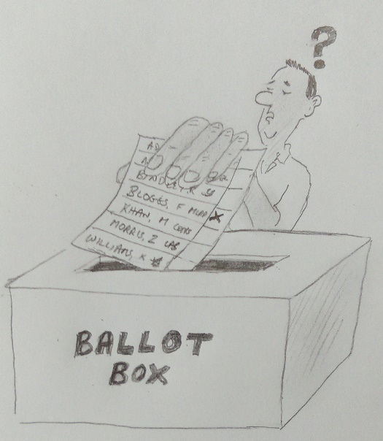
General elections
These elect MPs to the House of Commons in the Westminster Parliament. They are held every five years since the Fixed-Term Parliament Act (2011). Because the party with the largest number of MPs forms the government, general elections effectively allow voters to choose the next government. The most recent general election was in May 2015 which was won by the Conservative Party.
To vote in a UK general election you must fulfil the following criteria:
- You must be over 18
- A British citizen, a qualifying commonwealth citizen or a citizen of the Irish Republic
- Not be in prison
- Not be in the House of Lords (barred only from general or by-elections)
- Not be guilty of electoral corruption

By-elections
These happen in a single constituency between general elections when an MP resigns, retires or dies. Recent by-elections include the Clacton by-election in 2014 when the Conservative MP, Douglas Carswell, resigned from the Conservative Party in order to stand as a UKIP candidate. He was re-elected as the constituency’s MP. He won the constituency (also known as a ‘seat’ in parliamentary terms) in the 2015 general election, making him the only UKIP MP in parliament.

Changing between parties
Although it is the honourable thing to do, MPs do not have to resign their seat in order to change parties. They can simply switch parties (as Churchill did more than once). This is known as ‘crossing the floor of the House’.
You ought to know this phrase!

Local elections
These take place at least every four years and elect councillors to represent wards (an electoral district) in a local council. Wards are smaller than constituencies in the Westminster Parliament.
European elections
These are elections for Members of the European Parliament (MEPs) in Strasbourg and Brussels. The UK has 73 of the 751 MEPs. They happen every five years.
Elections to devolved legislatures
In some regions of the UK there are devolved assemblies (the Scottish Parliament, the Welsh Assembly, and the Northern Ireland Assembly). These have powers, transferred from Westminster, to legislate on matters of particular relevance to their citizens. Elections to each legislature are held every four years.

EXAMPLES:
Examples of elections are explored in greater depth in Chapter 2. For now, it is sufficient to note the following.
2015 General Election
The most recent UK general election was in May 2015. It resulted in a Conservative Party majority of just 12 seats. The opinion polls predicted a hung parliament (one in which no political party has a majority or overall control). Issues which influenced the outcome of the election included Britain’s budget deficit and the state of the economy; the image of the Labour leader, Ed Miliband; immigration; the NHS; Britain’s membership of the EU; and the extent to which the Liberal Democrats could be trusted to honour their election pledges (after the university tuition fee U-turn in 2010). ‘Fringe’ parties, notably the SNP, UKIP and the Green Party, had an impact on the fortunes of the ‘mainstream’ parties (the Conservatives, Labour and the Liberal Democrats). There was a TV debate between seven party leaders, further illustrating the fragmentation of British politics.

Opinion Polls & Exit Polls
Opinion polls are surveys of voters which seek to discover people’s voting intentions and attitude to party policies, party leaders, or party competence. They are conducted by specialist organisations, such as Mori or YouGov. They usually operate within a 3% margin of error, although in 1992 they showed a 9% error and in 2015 they wrongly predicted a hung parliament. They are less reliable than exit polls which are surveys conducted on the day of the election (polling day) and which ask voters how they have actually voted. The exit polls in 2015 were remarkably accurate.
There are two effects noticeable with opinion polls. The boomerang effect is where polls predict that a particular party is likely to win which has the effect of galvanising support for the other main party. This happened in 1992. The polls clearly predicted that Labour was going to win, so Conservative voters came out in force and, much to the surprise of Labour, the conservatives won with the biggest share of the vote since 1945. Today opinion polls are not allowed to be published on polling day (the day of the election) in case they influence the result.
Conversely, opinion polls may cause a bandwagon effect. This is where a party which seems unlikely to win, perhaps because it has lost several successive elections, appears to be leading in the polls. Supporters for that party are galvanised into voting knowing that, finally, there is a realistic chance of the party being elected into government. This happened in 1997 for Labour. No one was more surprised than Tony Blair that the Labour Party won, but they had been ahead in the polls and voters began to believe they had a realistic chance of winning.
These terms are very useful!

2010 General Election
The 2010 general election resulted in a hung parliament and a coalition government was formed between the Conservatives and the Liberal Democrats. In order to win an overall majority a party needs to win 326 of the 650 seats in the House of Commons, but the Conservatives won just 306 and so formed a coalition with the Liberal Democrats who had won 57 seats. The issues in the 2010 election were the budget deficit and the strength of the economy; the image and the competence of Labour’s leader, Gordon Brown; the NHS; immigration; and, for the Lib-Dems, university tuition fees (which they pledged to scrap). Gordon Brown was challenged on the issue of immigration by a life-long Labour supporter, Gillian Duffy, who he called a ‘bigot’ (someone who is extremely prejudiced). The resulting scandal, nicknamed ‘Bigotgate’, was highlighted as an issue by the media (although it had little real impact on people’s voting intentions).
The 2010 election also saw the first televised debate between the leaders of the three main parties. Nick Clegg, the Liberal Democrat leader, was considered to have performed best in the debates. In the first of three debates both David Cameroon, the Conservative leader, and Gordon Brown, the Labour leader, repeatedly used the phrase ‘I agree with Nick’ in order to appear as though they were reasonable people and ‘centre-ground’ politicians. Cleggs’s performance in the debates led to a surge in personal support for him in the opinion polls in what the media dubbed ‘Cleggmania’. Arguably this resulted in more votes for the Liberal Democrats, but fewer seats: down from 62 to 57.

HARD STUFF:
Seats and Votes
It is possible to gain more votes that your nearest rival party in UK general elections, but still fewer seats! This is because it is not the national share of the votes that matters, but whether you have concentrated support in terms of votes in enough constituencies: it is seats, not votes, which matter. Labour do better at winning urban seats, where their votes are concentrated, and the Conservatives do better at winning rural seats, where their votes are concentrated.
It is therefore possible for a party which loses an election to have a greater share of the vote than the party which wins. This happened in 1951, when the Conservatives gained more votes than Labour, but fewer seats, and in February 1974 (there were two general elections in 1974) when the Conservatives won more votes, but Labour won more seats.
This is useful to know!

ADDITIONAL STUFF
Campaigns
The official election campaign begins on the day that parliament dissolves (ends its sittings) and finishes on polling day (the day of the election). Usually this is a period of six weeks or so. During this time neither parliament nor the Cabinet (the committee of senior MPs which manage the government) meet, unless there in an emergency which requires them to be recalled. Instead the civil service (the body of officials who work for the government) runs the country.
Canvassing
This is the process by which candidates try to win the support of voters. It involves posting leaflets through household letterboxes, knocking on doors and attending hustings (public meetings candidates from all parties can be questioned by voters). It is called canvassing because in the 18th century candidates had oil paintings of themselves which they could roll up and take from meeting to meeting, rather like a campaign poster.
Manifesto
This is a document which a political party publishes to outline all its policies. It allows the voter to make an informed choice as to who to vote for. These days manifestos are published online.
Mandate
A mandate is the authority to carry out a policy based on a manifesto promise. Arguably a government that wins a large majority (like Labour in 1997) has a strong mandate from the people.
Legitimacy
This is the right to govern. Arguably a government with a large majority is more legitimate than a government which has won a smaller majority. In 2005 Labour won with just 35% of the overall share of vote and some argued it lacked legitimacy.
Vote, ballot, franchise, suffrage
These are words which are almost interchangeable. To ‘cast’ a vote is to choose between two or more candidates or issues. A ballot is a system of voting: in the UK we have a secret ballot (no one knows how you vote). Franchise is the right to vote. Suffrage also mean the right to vote. In the UK we have ‘universal suffrage’ (all eligible adult citizens have the right to vote; there is no longer any discrimination on the grounds of gender).

Constituency
A geographical area represented for which representatives are chosen in an election.

AN EXTRA CAUTIONARY NOTE ON REFERENDUMS
Students sometimes confuse referendums with elections. The two are not the same. Elections require that a candidate is elected to office. Referendums are a vote on a single issue (eg whether Scotland should become independent) and are not about electing people to posts. Referendums are therefore an expression of the views of voters at a given moment on a particular issue. Most referendums in the UK are on local or regional issues. There have only been two national referendums in the UK. In 1975 voters were asked whether Britain should remain in Europe and in 2011 voters were asked whether the UK should change its voting system to AV (see chapter 3). There is likely to be another UK-wide referendum in 2017 on whether Britain should remain within the EU.

